***ATA Marital Arts - Chesterfield 17361 Edison Ave.***

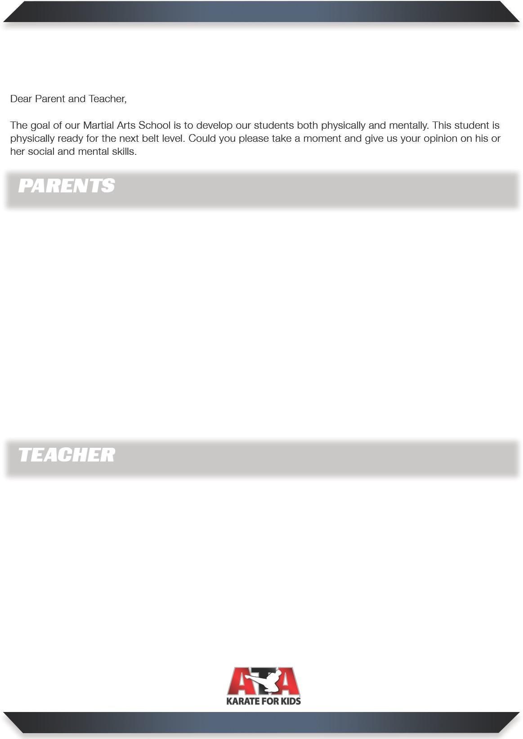

***Chesterfield, MO 63005***

***636-532-4ATA (4282)***

[***www.stlata.com***](http://www.stlata.com/)

1. My child has been practicing the lesson of the month ... YES NO
2. My child has attended a minimum of two classes weekly ... YES NO

.

1. My child has shown improvement in:
   1. School ...
   2. Physical Fitness ...
   3. Attitude ...
2. I am current on my tuition payments ...

YES NO

YES NO

YES NO

YES NO

CURRENT BELT RANK:

DATE ACHIEVING BLACK BELT:

Student’s Signature: Parent’s Signature:

1. has been doing satisfactory or better work in my class and is receiving passing grades while being respectful to the teachers and other students.
2. l am/am not (please circle) interested in having your martial arts school do a motivational talk about respect and self-control in the classroom.
3. The best time to contact me is at (phone or email).

Teacher’s Signature: __________________________ Please print:

If our martial arts students do not meet any of these qualifications, either at home, school, or in our classes, we will hold them at the current rank until satisfactory improvement has been shown.